CO3-AT2 – Question 28
Name: R.Gautham Krishna
Register No: 192421128
Subject: Design and Analysis of Algorithms Faculty: Dr. F. Mary Harin Fernandez

Q28. Case Study: Online Book Search System Using Binary Search
1. Problem Statement
An online bookstore maintains a large catalog of books and requires a fast search system to find books based on their title or ID. Searching every book one by one using Linear Search becomes slow when the number of books increases.
The objective of this case study is to improve book-search efficiency using the Binary Search algorithm. Binary Search uses the divide-and-conquer principle by repeatedly dividing the sorted catalog into two halves until the required book is found.

2. Objectives
- Study book searching using Binary Search.
- Maintain a sorted catalog of books.
- Implement Binary Search for quick book access.
- Compare Binary Search with Linear Search.
- Analyze the time complexity of the search process.
- Understand the divide-and-conquer principle.
- Identify the requirements for efficient online book searching.
- Justify the use of Binary Search for large book catalogs.

3. Understanding the Case Study
An online bookstore may contain thousands or millions of books.
Example sorted catalog:
Book ID | Book Title
101 | Algorithms
102 | Computer Networks
103 | Database Systems
104 | Operating Systems
105 | Software Engineering
Suppose the user searches for "Operating Systems".
Binary Search first checks the middle element and compares it with the search title.
- If the search title is equal to the middle element → book is found.
- If the search title comes before the middle element → search the left half.
- If the search title comes after the middle element → search the right half.
Therefore, unnecessary books are eliminated after every comparison.

4. Key Requirements
Requirement 1: Sorted Catalog
The book catalog must be sorted by book ID or title before Binary Search can be applied.
Requirement 2: Fast Access
The system should return search results quickly even when the catalog contains a large number of books.
Requirement 3: Unique Identification
Each book should have a unique ID or searchable title.
Requirement 4: Search Input
The system should accept a book ID or title from the user.
Requirement 5: Search Result
The system should display whether the requested book is available and provide its position/details.

5. Key Challenges
Challenge 1: Large Number of Books
An online bookstore may contain thousands or millions of books. Searching each book sequentially is inefficient.
Challenge 2: Search Time
Linear Search may require checking many elements before finding the required book.
Challenge 3: Maintaining Sorted Data
Binary Search requires the catalog to remain sorted.
Challenge 4: Frequent Catalog Updates
Adding or removing books may require maintaining the sorted order.
Challenge 5: Efficient Access
The system should provide quick access to book information.

6. Divide and Conquer Approach
Binary Search follows the Divide and Conquer principle.
Step 1 – Divide
Find the middle element of the sorted catalog.
Sorted Book Catalog
[101 102 103 104 105 106 107]
|
Middle
↓
104
Step 2 – Compare
Compare the search value with the middle element.
Step 3 – Select Half
If the required book is smaller, search the left half.
If the required book is larger, search the right half.
Step 4 – Repeat
Continue dividing the selected portion into two halves.
Step 5 – Find Result
When the book ID matches the middle element, the book is found.

7. Binary Search Algorithm
BinarySearch(BookCatalog, Target)

1. Set low = 0
2. Set high = length(BookCatalog) - 1

3. While low <= high:
mid = (low + high) // 2

If BookCatalog[mid] == Target:
Return "Book Found"

Else if BookCatalog[mid] < Target:
low = mid + 1

Else:
high = mid - 1

4. Return "Book Not Found"

8. System Architecture
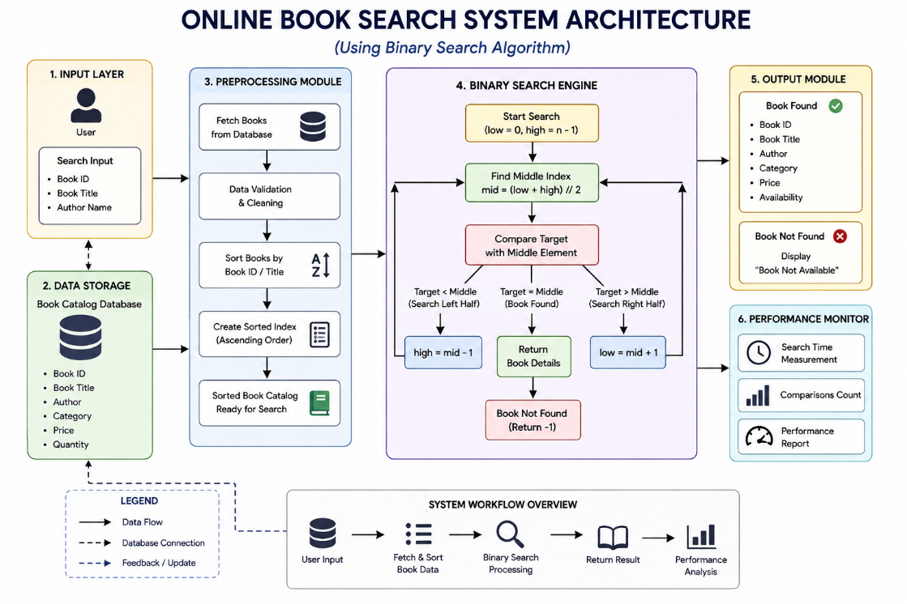
9. Python Program
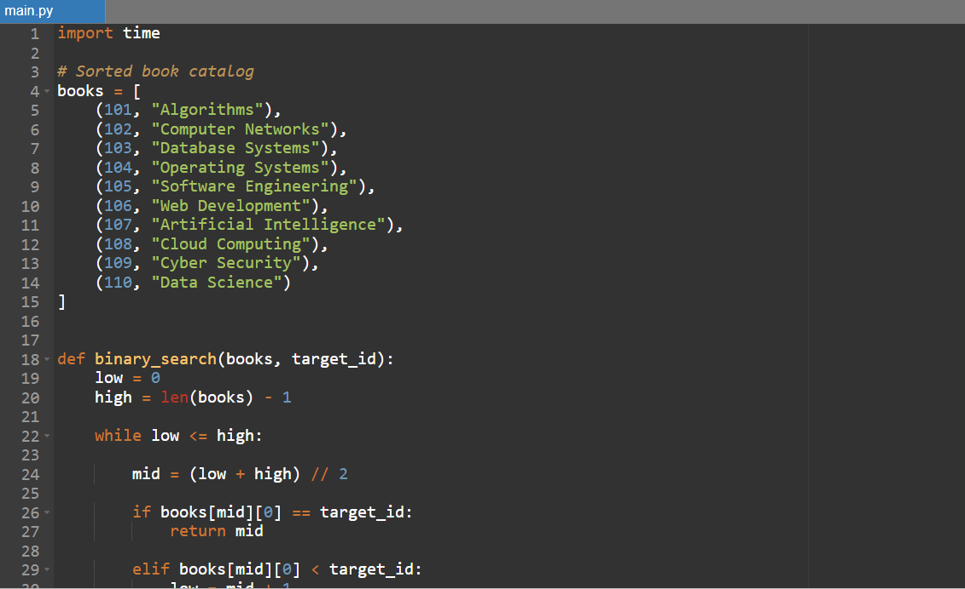
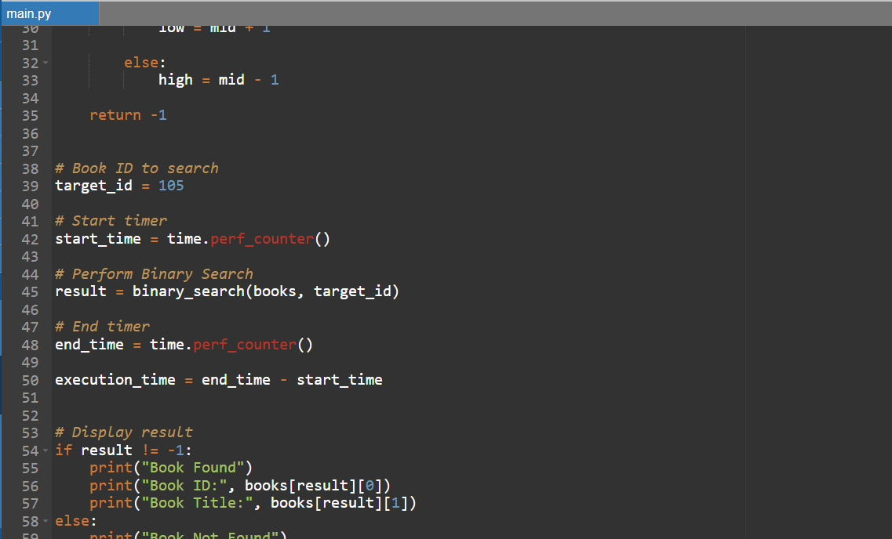
10. Output
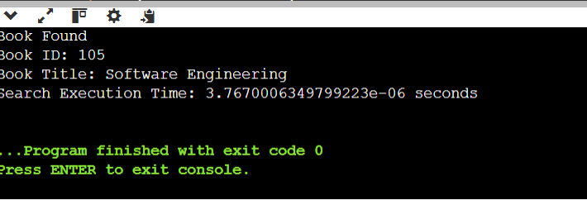
11. Performance Analysis
Method | Time Complexity | Search Performance | Requirement
Linear Search | O(n) | Slower for large catalogs | No sorting required
Binary Search | O(log n) | Very Fast | Sorted catalog required
Example
For a catalog containing 1,000,000 books:
- Linear Search may require up to approximately 1,000,000 comparisons in the worst case.
- Binary Search requires approximately 20 comparisons in the worst case because:
log₂(1,000,000) ≈ 20
This demonstrates why Binary Search is highly suitable for large sorted book catalogs.

12. Time Complexity
Operation | Complexity
Best Case | O(1)
Average Case | O(log n)
Worst Case | O(log n)
Binary Search reduces the search space by half after every comparison.
Therefore:
n → n/2 → n/4 → n/8 → ... → 1
The number of comparisons grows logarithmically.

13. Space Complexity
For the iterative Binary Search used in the program:
Space Complexity = O(1)
Only a few variables such as low, high, and mid are required.
If a recursive implementation is used, the auxiliary space becomes:
O(log n)
because of the recursive call stack.

14. Advantages
- Very fast searching.
- O(log n) search complexity.
- Efficient for large catalogs.
- Reduces the number of comparisons.
- Simple to implement.
- Requires very little extra memory.
- Suitable for indexed book databases.
- Provides predictable search performance.

15. Limitations
- The catalog must be sorted.
- Maintaining sorted order can require additional processing.
- Not ideal when data changes very frequently.
- Insertion into an array-based sorted catalog can require shifting elements.
- Binary Search is less suitable for completely unsorted data.

16. Applications
Binary Search can be used in:
- Online bookstores
- Library Management Systems
- Student Record Systems
- Employee Databases
- Product Catalogs
- Dictionary Applications
- Telephone Directories
- Banking Systems
- Inventory Management Systems
- Searchable databases

17. Analysis
The Binary Search algorithm significantly improves the efficiency of an online book search system. Instead of checking every book individually, it compares the search value with the middle book and eliminates half of the search space after each comparison.
For a small catalog, the difference between Linear Search and Binary Search may not be significant. However, for a large online bookstore containing thousands or millions of books, Binary Search provides much faster searching.
The main requirement is that the book catalog must be sorted or indexed. If the catalog is frequently updated, maintaining the sorted structure can introduce additional cost. However, when searches are frequent and the catalog is relatively stable, the benefit of O(log n) searching is significant.

18. Trade-off
Search Efficiency
- Binary Search provides O(log n) search time.
- Only a small number of comparisons are required.
- Performance remains efficient as the catalog grows.
Maintenance Cost
- The catalog must remain sorted.
- Adding or removing books may require maintaining the sorted order.
- Updating the index may require additional processing.
Overall Trade-off
Frequent searches + relatively stable catalog → Binary Search is highly suitable.
Frequent updates + constantly changing data → Other data structures such as balanced search trees or hash tables may be more appropriate.

19. Why Binary Search is Appropriate
Binary Search is appropriate for an online bookstore because:
- Book catalogs can contain a very large number of records.
- Book IDs can be maintained in sorted order.
- Users expect quick search results.
- O(log n) is significantly faster than O(n) for large datasets.
- The algorithm requires only O(1) additional space when implemented iteratively.
- The divide-and-conquer approach efficiently reduces the search space.

20. Conclusion
The case study successfully demonstrates how Binary Search improves the efficiency of an Online Book Search System. By maintaining a sorted catalog, Binary Search repeatedly divides the search space into two halves and quickly identifies the requested book.
The algorithm has a worst-case time complexity of O(log n) compared with O(n) for Linear Search. Therefore, Binary Search is highly suitable for online bookstores with large and relatively stable catalogs where fast and frequent searches are required.
The main limitation is the requirement for sorted data and the additional maintenance cost when books are frequently added or removed. Overall, Binary Search provides an efficient, simple, and scalable solution for searching large online book catalogs.

